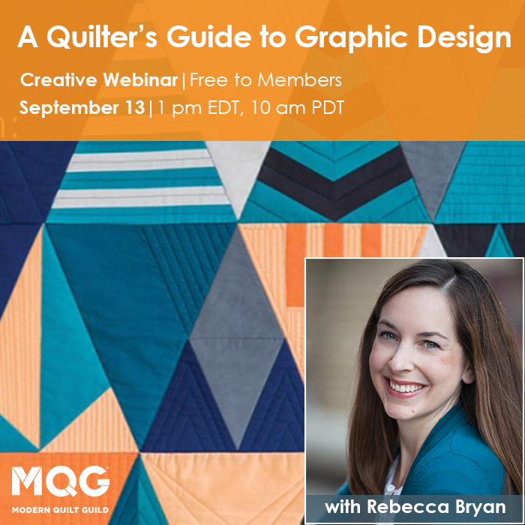

Sign-Up: Graphic Design Challenge and Mini Quilt Swap

Your Name
Your Email
Desired color palette?
Favorite colors
Least favorite colors
Favorite designers
Favorite shape?
(square, HST, hexie etc.)

Please complete by December 13.
Email form to denvermetromodernquiltguild@gmail.com

